Hello World RESTful Web Service

URL http://localhost:8083/hello in both chrome browser and postman

- In network tab of developer tools show the HTTP header details received

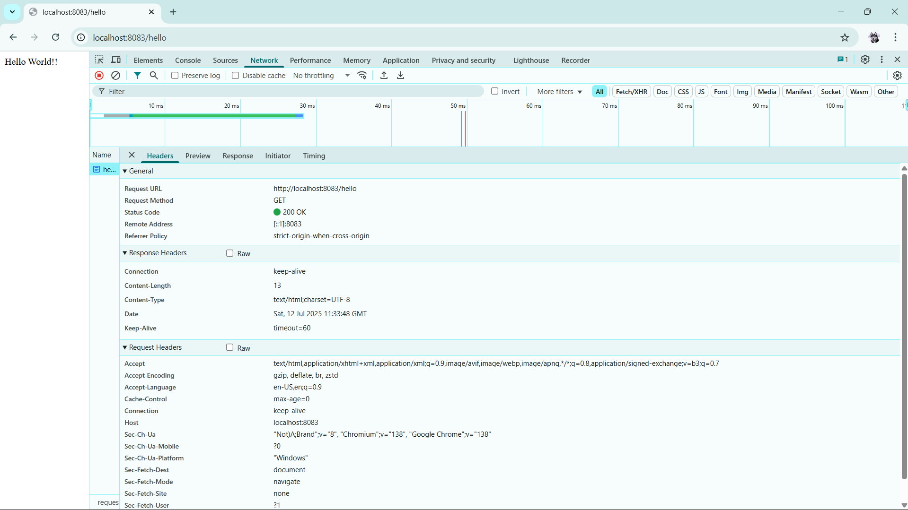

- In postman click on "Headers" tab to view the HTTP header details received

